SIMATS ENGINEERING
SAVEETHA INSTITUTE OF MEDICAL AND TECHNICAL SCIENCES
NAME: K. Hema sai Siddartha
DATE:08/10/2026
LAB EXP: 14
Reg Mo: 192325036
Course Code/ Name: DSA0602 / Data Handling and Visualization
Set:14
Dataset: Survey Results
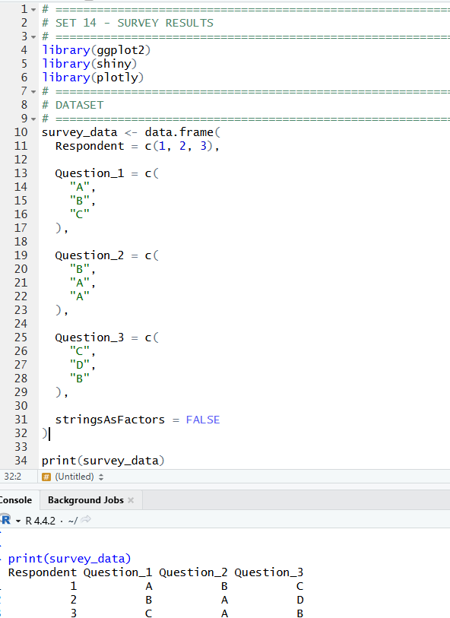
1. Create a stacked bar chart to display the distribution of answers for Question Label the chart elements.
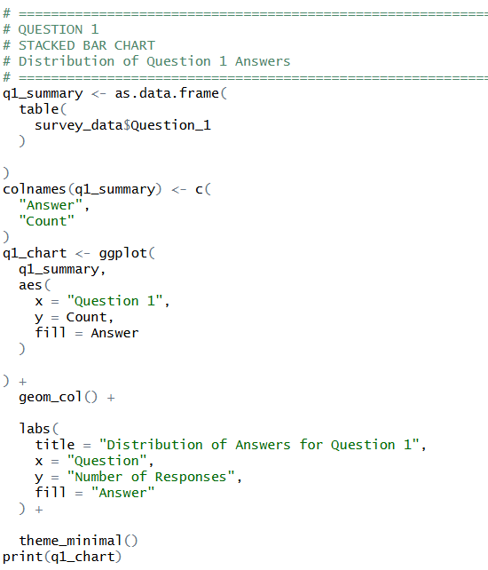
OUTPUT:
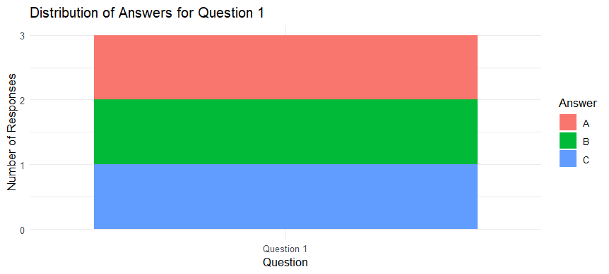

2. Generate a radar chart to visualize the overall pattern of responses across all three questions.
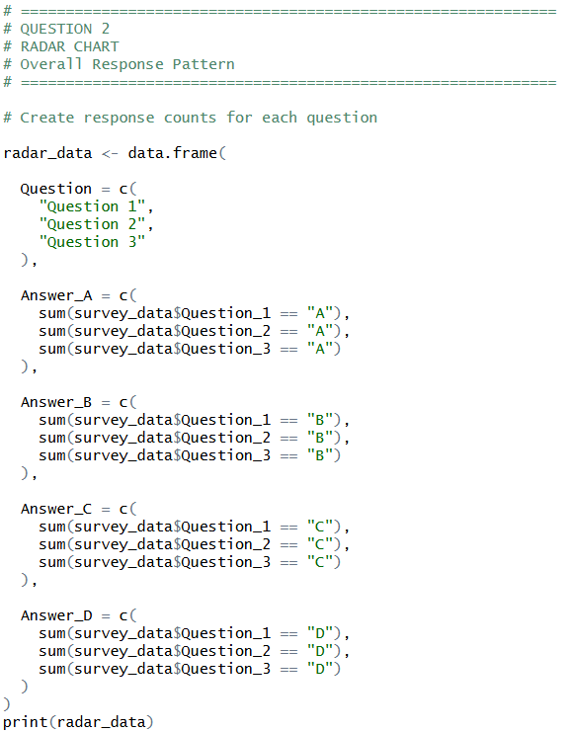
OUTPUT:
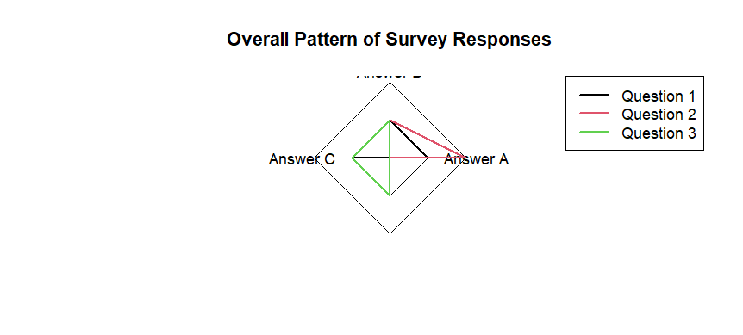

3. Build a table to show the survey response data for each respondent. Label the table elements.
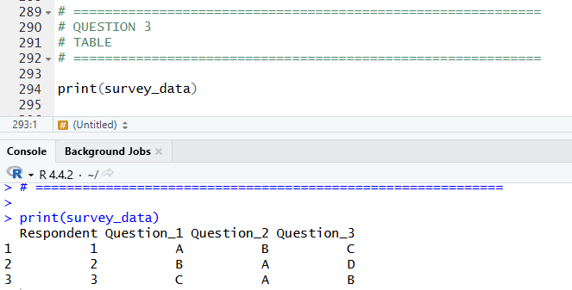

4. Develop a Tableau dashboard combining the stacked bar chart, radar chart, and the table for interactive exploration of survey responses.
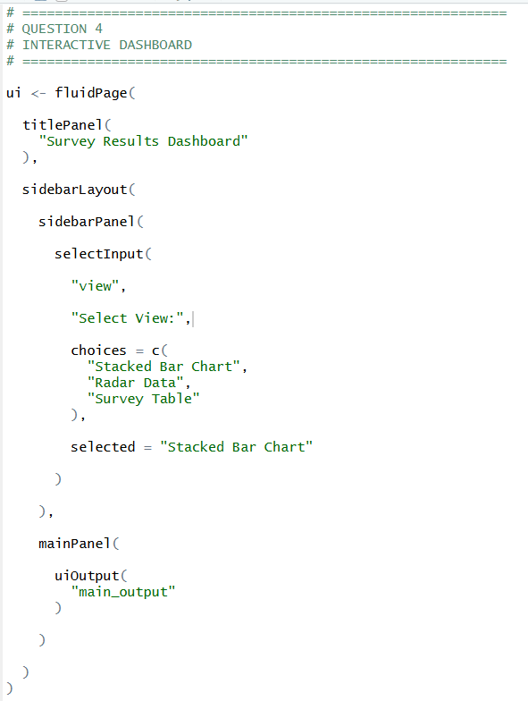
OUTPUT:
